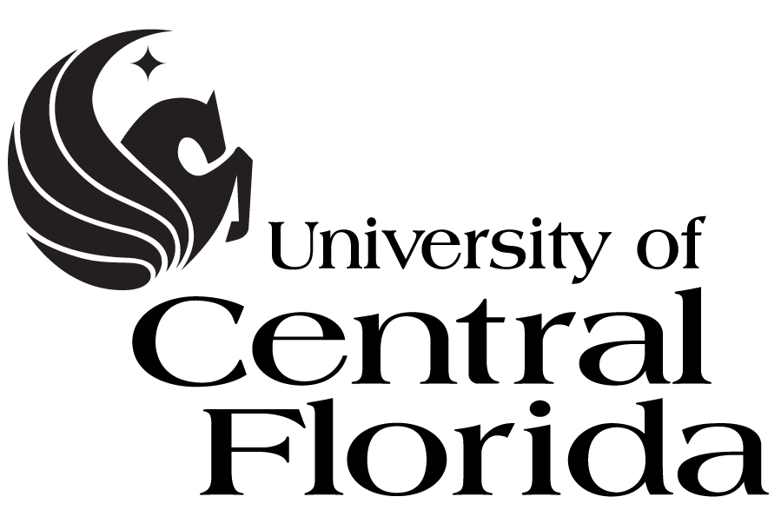
Board of Trustees
Advancement Committee Meeting
May 22, 2014
Live Oak Center

MINUTES

CALL TO ORDER
Trustee Richard Crotty, chair of the Advancement Committee, called the meeting to order at
9:45 a.m. in the Live Oak Center on the UCF Orlando campus. Committee members Olga Calvet, Weston Bayes, Clarence Brown, Alex Martins, and Beverly Seay were present. A quorum was confirmed. Trustees Robert Garvey and Reid Oetjen were present.

MINUTES
The minutes from the May 22, 2014, meeting were approved as written.

ADVANCEMENT COMMITTEE UPDATES
University and Government Relations
Dan Holsenbeck, Vice President for University Relations, noted that UCF recently hosted Marshall Criser, Chancellor of the State University System of Florida. Chancellor Criser was given a tour of UCF and the Central Florida Research Park. Holsenbeck provided the committee with statistics about the research park that were also shared with Criser during his visit.

On behalf of University Marketing and Communications, Holsenbeck reported that UCF has been featured in nearly 10,000 media stories through April of this fiscal year; WUCF TV surpassed its community fundraising goals for this fiscal year ending June 30; and Pegasus Magazine has received numerous awards this past year.

Holsenbeck reported the legislative results for the 2014 session. Dr. Hitt provided an update to the committee regarding the downtown presence for which $2 million in reoccurring funding was approved to begin planning.

Alumni, Development, and Foundation

On behalf of Bob Holmes, Joyce Henckler, Chief Development Officer for the UCF Foundation, reported that the Foundation has currently secured $130 million towards the campaign, with $80 million in open asks.

The alumni association had a very busy graduation season, hosting Senior Send Off events within the colleges, as well as in cities around the county with a regional alumni chapter.

Watch parties to cheer on Blake Bortles in the NFL draft were hosted in several regional locations.

Guest Speaker – Katie Korkosz,
Ms. Korkosz, the associate director of development for the College of Nursing, spoke to the committee about her UCF experience, beginning as a student and now as an employee and fundraiser.

Chair Crotty adjourned the meeting at 10:37 a.m.

