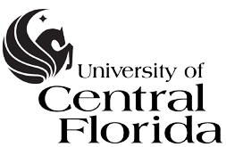

Board of Trustees

Strategic Planning Committee
May 3, 2016
President’s Board Room

MINUTES

CALL TO ORDER

Trustee Clarence Brown, chair of the Strategic Planning Committee, called the meeting to order at
3:35 p.m. Committee members Robert Garvy, Keith Koons, and Cait Zona were present. Chairman
Marcos Marchena and Trustee David Walsh were present.

MINUTES

The minutes from the March 24, 2016, meeting were approved as submitted.

NEW BUSINESS

Thad Seymour, Senior Advisor to the Provost for Strategic Planning, presented draft #4 of the UCF Collective Impact Strategic Plan and welcomed any questions and comments. An additional meeting was requested before draft #5 goes before the full board. Comments will be sent to Dr. Seymour and he will summarize them and send them out.

Chair Brown adjourned the Strategic Planning Committee meeting at 5:10 p.m.

Respectfully submitted: ____________________________ ___________________

A. Dale Whittaker Date

Provost and Executive Vice President

